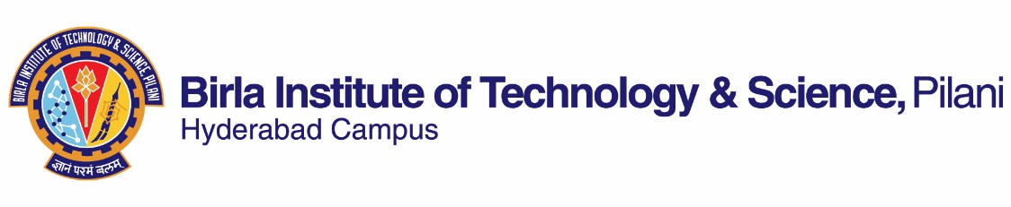

**FIRST SEMESTER 2021-2022**

**Course Handout (Part ‑ II)**

**Date: 18.08.2021**

In addition to part‑I (General Handout for all courses appended to the time table) this portion gives further specific details regarding the course.

**Course No. : CHEM G552**

**Course Title : Advanced Inorganic Chemistry**

**Instructor-in-charge : Prof. R. Krishnan**

**Instructor : Dr. Himanshu Aggarwal and Prof. R. Krishnan**

**Course Description :** Advanced coordination chemistry, reactions, kinetics and mechanism; advanced organometalic chemistry, bonding models in inorganic chemistry, inorganic chains, rings, cages and clusters; group theory and its applications to crystal field theory, molecular orbital theory and spectroscopy (electronic and vibrational); inorganic chemistry in biological systems.

1. **Scope and Objective of the Course:** Theories of coordination chemistry, electronic spectroscopy and magnetism of complexes, organometallic chemistry. Bioinorganic, medicinal and environmental inorganic chemistry.
2. **Text Book:** T1. “ Inorganic Chemistry” Huheey J. E., Keiter, Ellen A., Keiter, Richard L., Medhi, O.K.; 4th ed., Pearson.

T2. . I. Bertini, H. B. Gray, S. J. Lippard, J. S. Valentine, “Bioinorganic Chemistry”, Viva, 1998.

**Reference Books:** R1. "Concise Inorganic Chemistry",  Lee, J.D. 5th Edition,Wiley, India Edition.  
R2 "Inorganic Chemistry", Shriver, D.F.;  Atkins, P.W.; Overton T. L., Rourke, J. P., Weller, M. T., Armstrong, F. A.  4th edition, Oxford.  
R3  "Concepts & Models of Inorganic Chemistry" B. Douglas, D. McDaniel and J. Alexander 3rd Edn , wiley India.

R4. E. Ochiai, “Bioinorganic Chemistry: A Survey”, Academic Press, 2008.

1. **Course Plan:**

|  |  |  |  |
| --- | --- | --- | --- |
| **Lecture No.** | **Learning Objectives** | **Topics to be covered** | **Chapter in the Text Book** |
| 1-2 | Coordination chemistry | Bonding  VB theory applied to coordination compounds | **T1**: 12.1-12.7 |
| 3-6 | Crystal Field Theory (CFT) | Crystal field splitting; d orbitals in different crystal fields; applications of CFT | T1:Chapter 14: 428-444 |
| 7-8 | Structure Nomenclature | Structure – Nomenclature, Coordination numbers 1, 2, 3, 4, 5, 6, 7. Generalization about coordination numbers  Isomerism: Linkage and other types of isomerism  Chelate effect | T1:Chapter 15: 461-492 |
| 9 | Molecular orbital theory | Molecular orbital theory | T1:Chapter 14: 444-459 |
| 10-12 | Electronic spectra of complexes, Magnetic properties of complexes | Electronic spectra of complexes, Magnetic properties of complexes | T1:Chapter 15: 461-492 |
| 13-15 | Reactions of coordinated complexes | Reactions – Nucleophilic substitution reactions, Kinetics, Mechanisms | T1:Chapter 17 (542-569) and Lecture notes |
| 16-20 | Organometallic chemistry | The 18-electron rule  Metal-carbonyl complexes  Nitrosyl complexes  Dinitrogens  Alkyls  Carbenes, Carbynes, Carbides  Alkenes  Alkynes  Metallocenes  Catalysis by organometallic compounds  Stereo chemically non-rigid molecules | T1:Chapter 18 and Lecture notes |
| 21 | Bioinorganic chemistry | Introduction to Bioinorganic Chemistry | T2 |
| 22-24 | Metal ion storage | Metal ion storage, transport and biomineralization | T2(Ch 1) |
| 25-27 | Oxygen carriers | Oxygen carriers: Iron and copper in biological systems | T2(Ch 4) |
| 28-29 | Oxygenases | Oxygenation reaction: iron and copper | T2(Ch 5) |
| 30-32 | Electron transfer | Electron transfer and redox processes in biological systems | T2(Ch 6) |
| 33-34 | Metal-sulfur proteins | Metal-sulfur proteins and metalloenzymes | T2(Ch 7) |
| 35 | Photosynthesis | Photosynthesis and artificial photosynthetic models | T2(Ch 7) |
| 36 | Vitamin B12 | Cobalt in biological systems | T2(Ch 2) |
| 37-38 | Metal in medicine | Medicinal inorganic chemistry | T2(Ch 9) |
| 39 | Metal-Nucleic acid | Metal-Nucleic acid interactions | T2(Ch 8) |
| 40-41 | Environmental inorganic chemistry | Toxicity of metal ions and environmental bioinorganic chemistry | R4 |

**4. Evaluation Scheme:**

|  |  |  |  |  |
| --- | --- | --- | --- | --- |
| **Component** | **Duration** | **Weighting (%)** | **Date and Time** | **Nature of Component** |
| Class tests, Assignments and presentations | - | 40 | Continuous | Open Book |
| Mid Semester Test | 90 min | 28 | --/--/2021 | Closed Book |
| Comprehensive  Examination**\*** | 120 min | 32 | --/--/2021 | Closed Book |

1. **Chamber Consultation Hours**: To be announced in the class.
2. **Notices**: Notices, if any, concerning the course will be displayed on the Chemistry Department Notice Board as well as in CMS.
3. **Academic Honesty and Integrity Policy**: Academic honesty and integrity are to be maintained by all the students throughout the semester and no type of academic dishonesty is acceptable.
4. **Make-up-policy:** No make up for the assignments/class tests. May be granted only for genuine cases.

**Instructor-in-charge**

